Inland Valley Wildcats Track Club
Desire, Dedication & Discipline!
"TRACK IS NOT JUST A SEASON, BUT A WAY OF LIFE"

2nd Annual I.V. Wildcats TC
Speed Clinic

Price: $25/athlete
When: Saturday, January 26, 2013
Time: 10:00 am - 1:00 pm
Where: Paloma Valley High School
31375 Bradley Road Menifee, CA 92584

Appearance by 1984 Olympic Gold,
1988 Silver 4x400m Relay Medalist, and Actress:
SHERRI HOWARD

Contact Info:
Coach Kevin Williams, Sr.
Phone: (951) 345-3824
Club email address: ivwildcats@yahoo.com or mwtckddubu@yahoo.com
Club Website: www.menifeewildcatstc.ning.com
USATF/AAU Website: www.scausatf.org / www.aausports.com

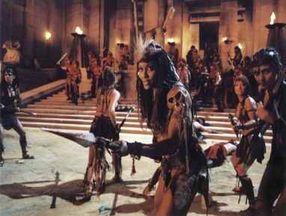

We are now on Facebook! (Tell a friend)

