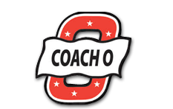

Coach O Event Management

Tryon International Indoor Facility Request Form

Name
Institution
Email Cell

List dates in order of preference 1-2 days Expected number of athletes
1.
2.
3.

Type of event:
Youth High School Collegiate Open Masters

Event Needs:
Facility Only Facility & Timer Facility, Timer, Officials

Return completed form to coachotrack@gmail.com You will be contacted within 7 business days once form has been received.

**A contract will be sent once dates are confirmed**

Questions can be directed to: Charles Oliver at (865) 207-4868 or at coachotrack@gmail.com

